**Kubernetes Task 1**

Setup minikube at your local and explore creating namespaces (Go through official documentation).

Open Power Shell in admin mode

Run the below command

>Set-ExecutionPolicy Bypass -Scope Process -Force; [System.Net.ServicePointManager]::SecurityProtocol = [System.Net.ServicePointManager]::SecurityProtocol -bor 3072; iex ((New-Object System.Net.WebClient).DownloadString('https://community.chocolatey.org/install.ps1'))

Once chocolatey completed check the list of chocolatey functions by running below command

>choco /?

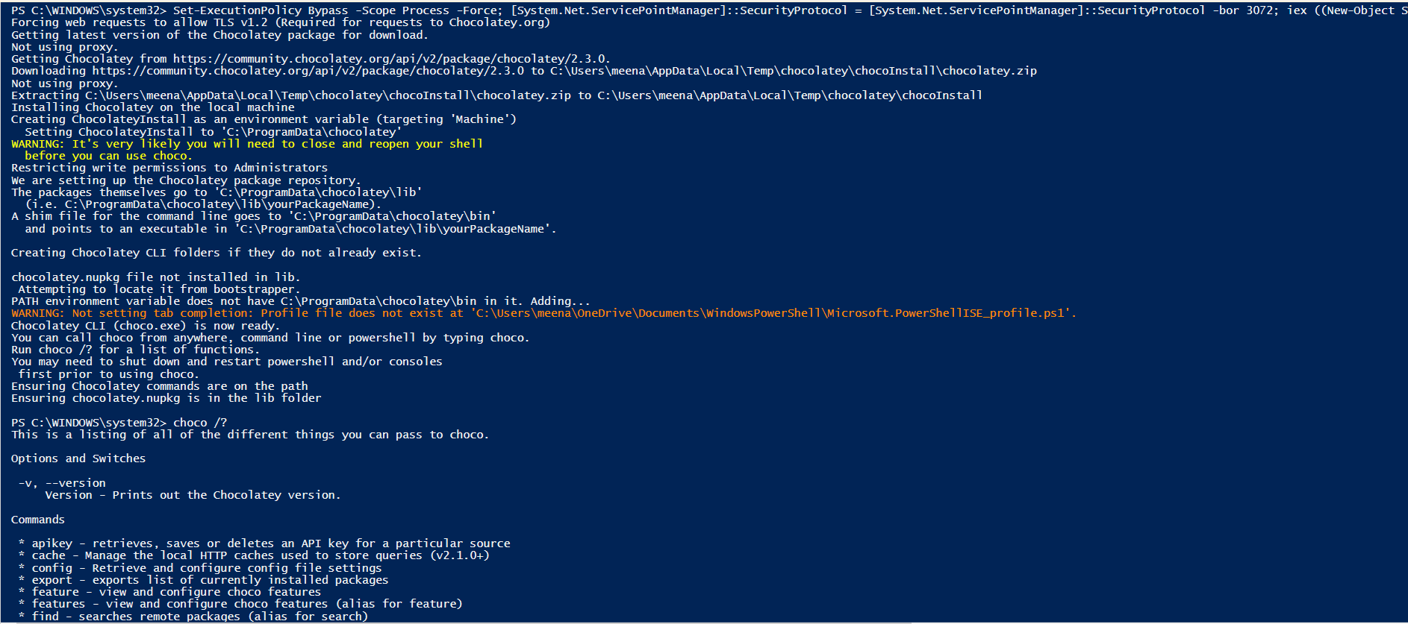

Installing Kubernetes Client in Windows PC

Open windows command prompt in admin mode

Run >choco install kubernetes-cli

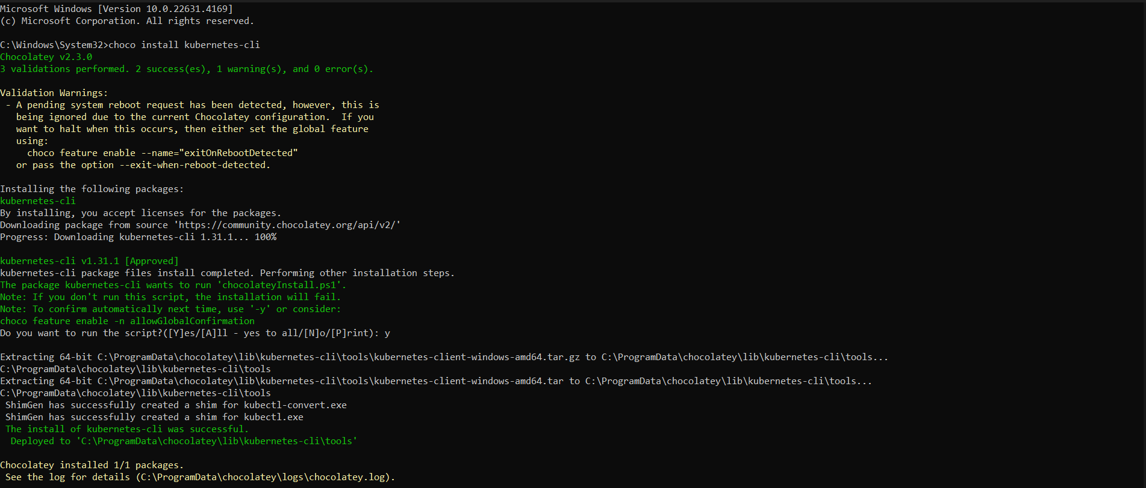

After completion of installation run this command to check version

>kubectl version –client

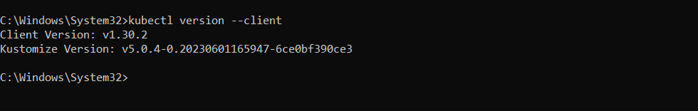

Navigate to your home directory with below cmd

>*cd %USERPROFILE%*

Create directory

>mkdir .kube

Go to the directory

>cd .kube

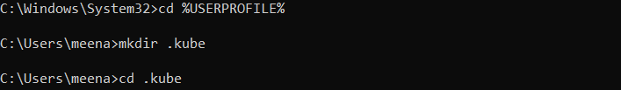

Go to the folder and create a txt file with name config

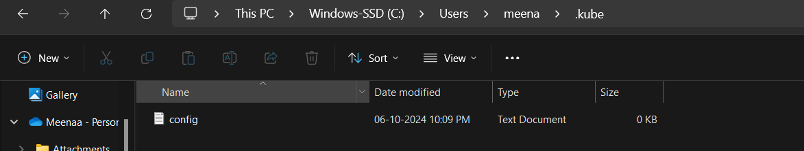

Install Minikube

In cmd prompt run the below command

>choco install minikube

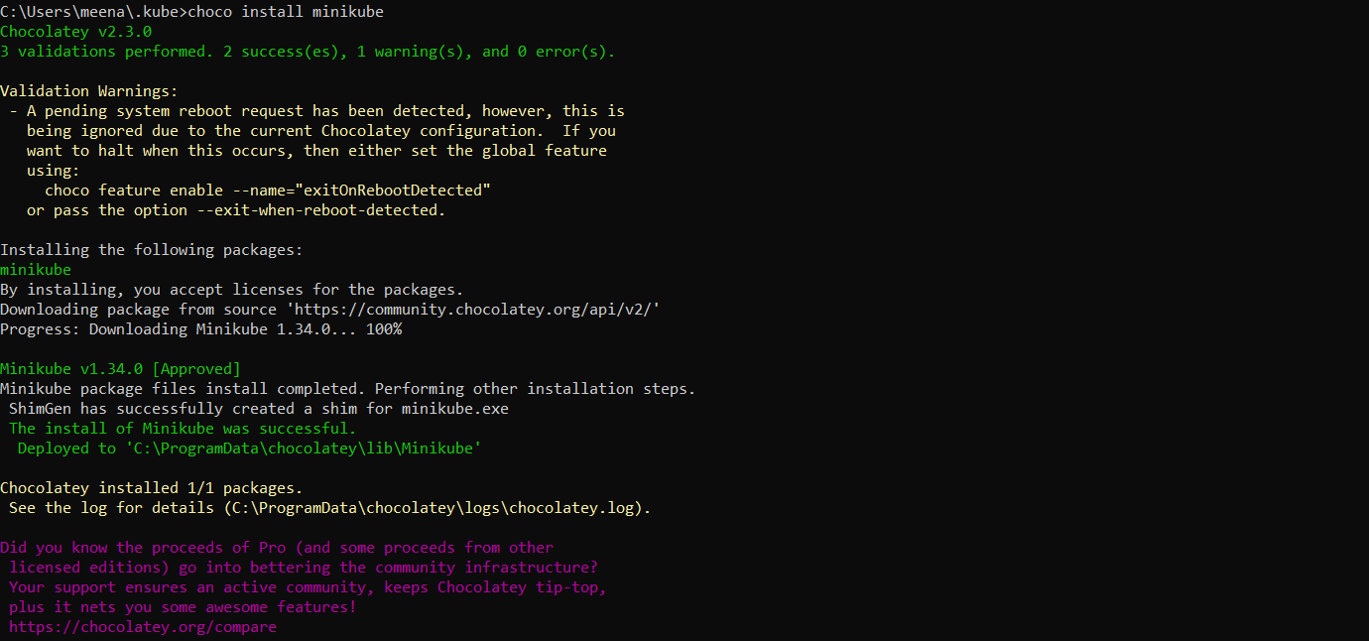

Start the cluster, if it doesn’t start then check docker service and start it and follow cmds in image

>minikube start

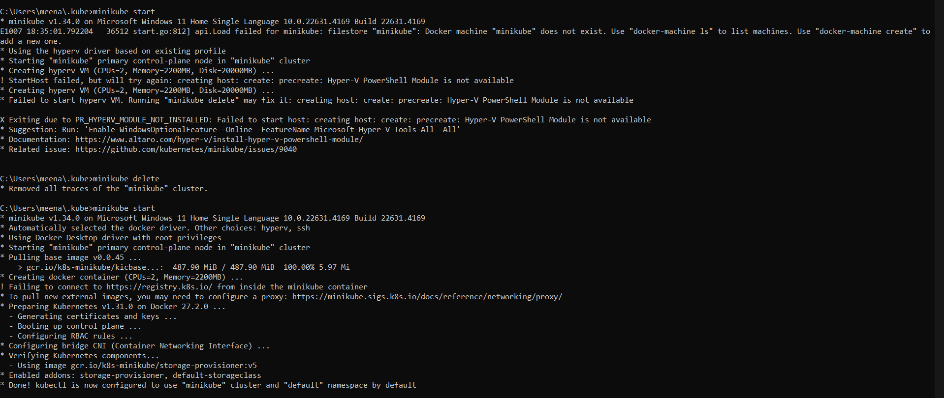

>minikube status

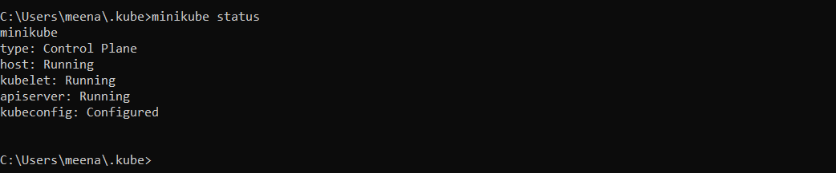

Run minikube dashboard to launch the dashboard

>minikube dashboard

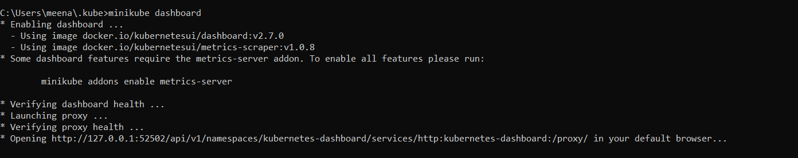

Kubernetes Dashboard

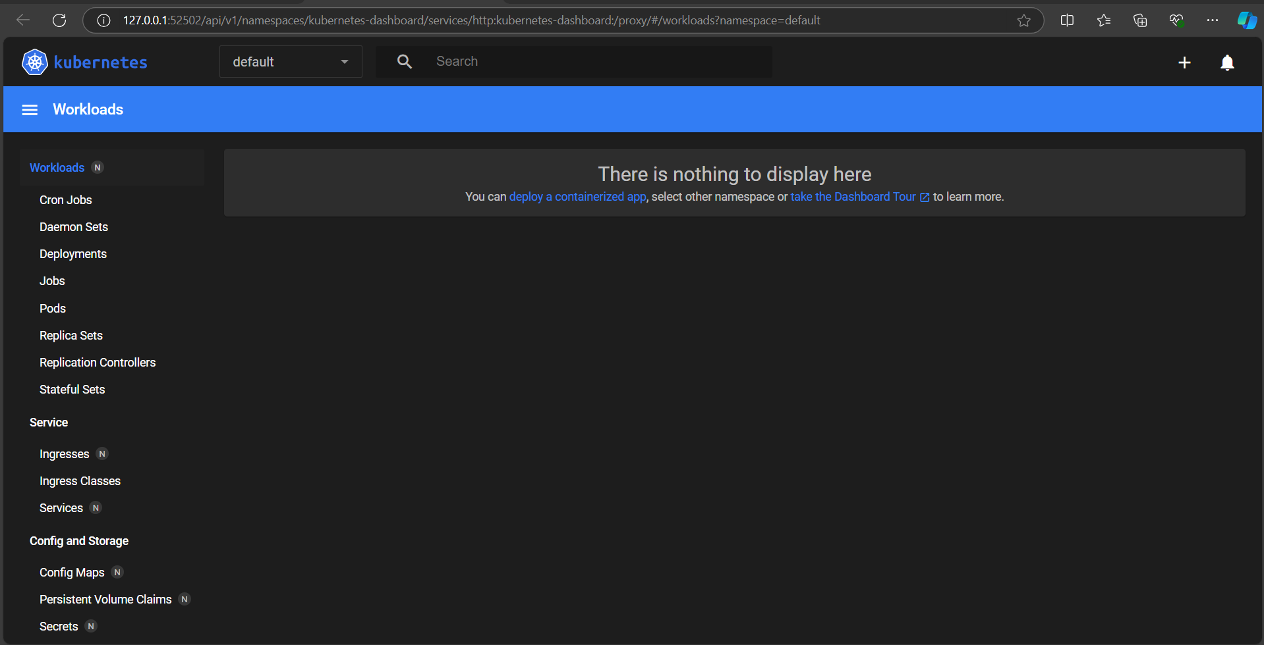

Kubectl version

>kubectl version –client

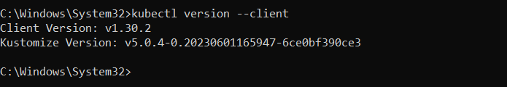

Name spaces in Kubernetes

>kubectl get namespaces

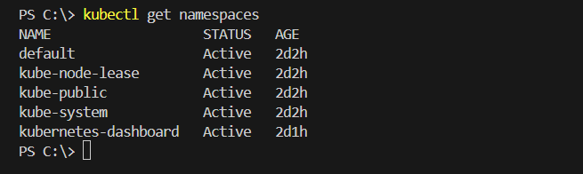

To check current namespaces being used

>kubectl config view --minify --output 'jsonpath={..namespace}'

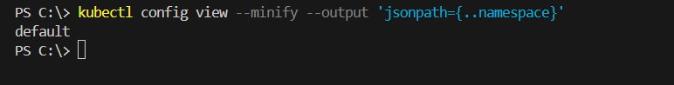

To create a new namespace

>kubectl create namespace <namespace name>

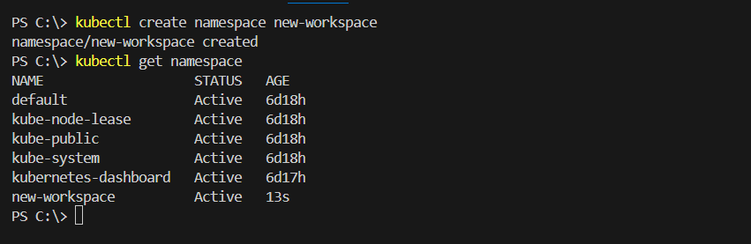

To change default namespace to new-workspace as current namespace

>kubectl config set-context --current --namespace=<namespace name>

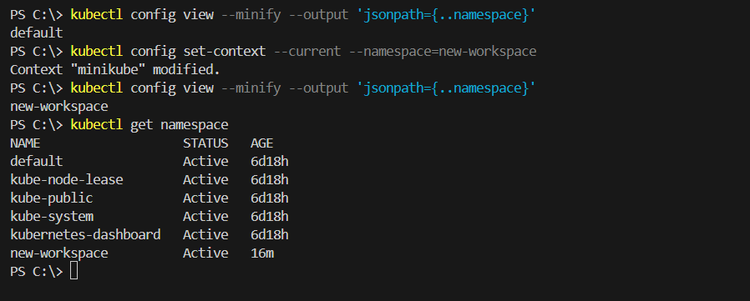

To delete the namespace

If you’re deleting the current namespace in K8s change the current namespace before deleting it

Else even after deleting the kubectl config will have the old namespace in it

>kubectl delete namespace <namespace name>

